You will need to import numpy and pandas both for these exercises. You can import it once in question 1 and then not again fro the rest of the assignment.

1. Create a numpy multi-dimensional array called planets. There will be 3 arrays in one. All of the elements will be strings. The first nested array will hold the words Mercury, Venus, Mars. The second will hold Jupiter, Saturn, Uranus. The last one will hold the word Pluto. Print the array.
2. Recreate the multidimensional array from #1 (yes, copy and paste it here). Now print out these strings: **"Venus is the second planet from the sun**." and **"Pluto is not a planet."**  Where the names of the planets are in the strings, you must be the values from the multidimensional array.
3. Create a numpy array holding the numbers 10 - 100 going up in increments of 10. (So 10 elements, highest 100, lowest 10, +10 on each one) Now create a slice called sub1 that starts at the 4th element and goes to the 9th and goes up by 2 each time. Now create a slice called sub2 which starts at the 1st element and goes to the 6th and goes up by 2 each time. Now create a variable called product and multiply sub1 and sub2 together and save it in product. Print the variable product. Now print the square root of sub2.
4. Create a list called classes with the strings in it: Algebra I, Intro to Business, Creative Writing. Now create a list called students with the value 30, 31, 29 in it. Now create a pandas Series out of classes and students, using classes as the index. Save this Series as att. Add a new element to the Series with a key of Programming and a value of 31. Now a print a newline. Finally, print only the elements in the Series where the att is less than 31.
5. Create a pandas Dataframe that looks like the image below using  Dictionary. Print it so the output looks like:  
   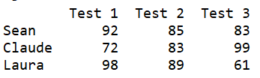  
   Now you are going print a newline. Now use the functionality of adding columns and rows and altering specific cells to create the Dataframe to look like as below. This should be your output:  
   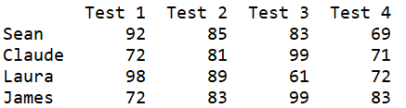  
     
   Hint: alter Claude's Test 2 score first. Then add the row for James. Then add the column for Test 4.
6. First you are going to create a dictionary called salesDict using this code:  
     
   salesDict = {'Samsung Galaxy S10': [769.34, 834.23, 900.12, 1021.12],  
   'iPhone X': [983.11, 881.21, 1210.32, 1100.34],  
   'Google Pixel 4': [1021.18, 1321.12, 832.14, 992.15]}  
     
   Now create a list called dates of four strings which are '01/01/2020', '01/02/2020', '01/03/2020', '01/04/2020'.  
     
   Now use the salesDict dictionary and the dates list to create a Dataframe called sales. Print sales. It should look like this:  
   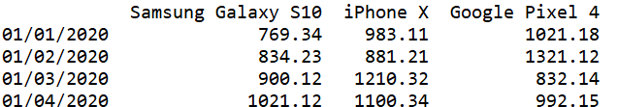  
     
   Now you are going to add 3 new columns to the sales Dataframe called "Mean", "Median" and "St Dev". In the Mean column, you will have the mean values for each date. In the Median column, you will have the median values for each date. In the St Dev column, you will have the Standard Deviation for each date.  
   Now drop the columns with the phone names. Print the final form of the sales Dataframe. Your output should look like this: